A Core Curriculum State Standards Aligned Discussion and Writing Prompt Guide for
Written by Barbara Stuber
Published by Margaret K. McElderry Books
Guide created by Debbie Gonzales
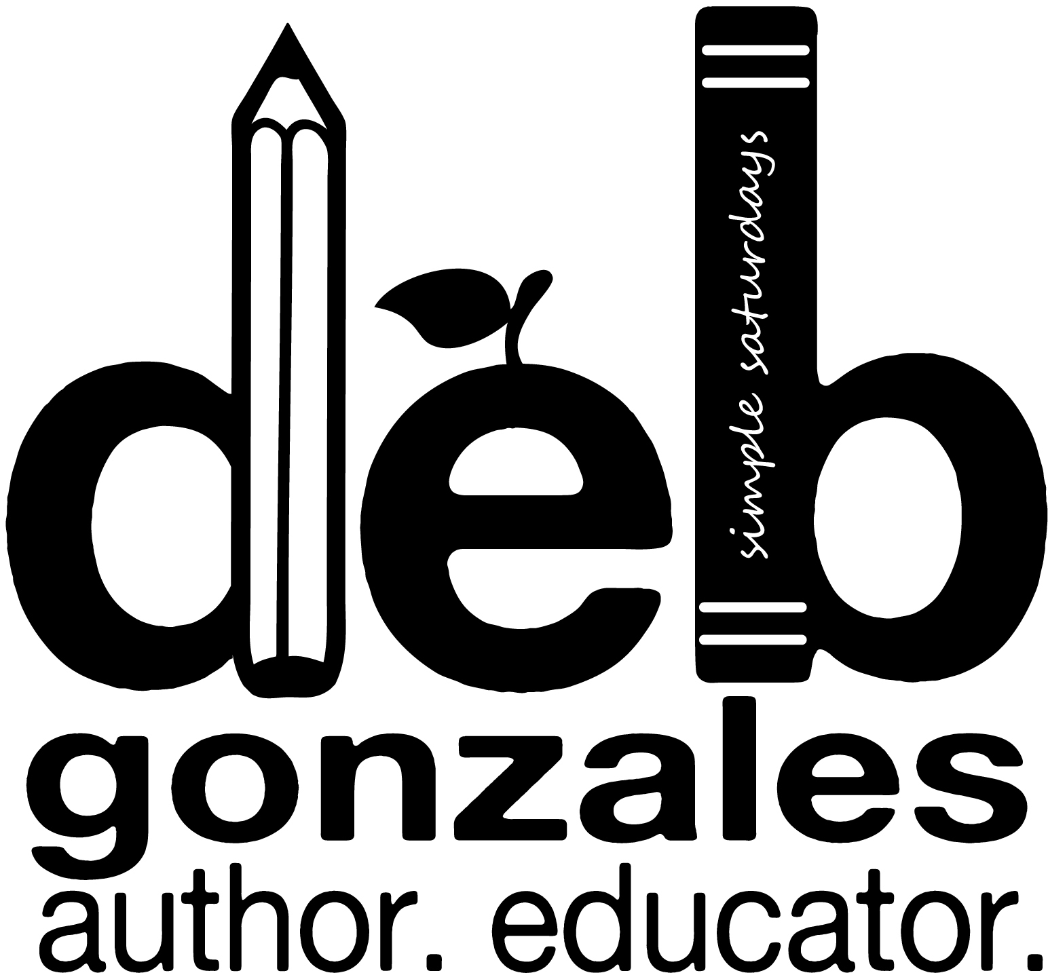
Table of Contents

Discussion Questions and Writing Prompts 3

Topics for Further Research 8

References 9

Core Curriculum State Standards Alignment:
English Language Arts Standards » Reading: Literature 10
English Language Arts Standards » Writing 10

Acknowledgments 13

Discussion Questions and Writing Prompts

Wars come in all sizes: whole world, playground, classroom, even inside your own skin. My mittens are fists. I wipe my eyes, furious that didn’t protect myself way back then. I should have stood up, fought back. But I didn’t. I didn’t know how. And now I’m still just me, still trying to ignore it.
…until today (6).
- Is it true that playgrounds and classrooms can be war zones? How so?
- Tell why Lily chose this day to protect herself.
- List prior situations in which Lily experienced prejudice as a result of her ‘skin.’
- Explain why Lily decided to walk out of Miss Arth’s class at this moment, rather than ignore the racial degradation?
- Describe the agitation, turbulence, and restlessness mounting within her.
  - Identify the source of her unrest.
  - Do you think these feelings gave her the strength to stand up for herself? How so?
- Patriotism is defined as being a devotion to one's country. Are there ways that the bullying acts of prejudice upon Lily could be considered as patriotic? How so?

- Writing prompt: “The most cited – and misunderstood – idea today is patriotism,” states Brenda K. (Teen Ink). Do you agree? Consider today’s political climate and/or that of the 50’s, the era during which Girl in Reverse is set to support your view. Cite instances in the novel to validate your argument.

“It’s not new. You wouldn’t remember it, but in grade school kids teased me all the time thinking I was Japanese. I didn’t even get what was going on.” I chew my thumbnail. “But it’s switched. Everybody’s prejudiced against Chinese people because they are Communists now and they’re trying to take over Korea. I’ve become the enemy because I am Chinese even though I’ve never been there and I know exactly zero about it (14).”
- Tell how Lily’s perception of allies and enemies shifted throughout the story.
- Discuss others’ perception of Lily in this regard? How did the notion of Lily being an ally and enemy shift?
- Define communism.
- Compare and contrast communism and American patriotism.
  - Are there ways the two are alike? Explain.
  - Are there ways that the two are different? How so?
- In today’s current culture, does terrorism pose a threat to the American way of life? How so?
- Define Lily’s desire. What does she want? Why can’t she have it? What stands in her way?

- Writing prompt: Craft a narrative in Lily’s point of view in defense of herself. Write it as if she were talking to you, directly. Let her explain her issues in light of today’s political climate. Allow her to compare the prejudices she endured in the 1950’s with those occurring today.

The Chows are not huddled behind the Bamboo Curtain. They are not avoiding themselves. They’re loud and colorful, making a living off their Chineseness (41).
- Define the term ‘Chineseness.’
- Explain why the Chow’s bold ‘Chineseness’ fascinates Lily.
- How is Lily caught between cultures, by not being fully American or fully Chinese?
- Tell why Lily is unable to ignore cultural differences any longer.
  - What sorts of events are taking place that are forcing her to consider cultural issues?
  - What sorts of emotional responses are taking place which warrant exploring her cultural heritage?
- Explain how someone can ‘avoid themselves.’

- Writing prompt: On page 49, Lily states that she feels guilty for standing up for her Chineseness. Explore the various expressions of ‘Chineseness’. Explain why Lily feels guilty while the Chow’s seem to fully embrace the notion of ‘Chineseness’ and why she cannot ignore it any longer.

The first film features a man who is finding homes in America for “war waifs” – unbaptized babies with mixed Asian and American blood that nobody wants. A beaming crowd of dignitaries applauds as the orphans are unloaded from military planes. The man and his wife wave, surrounded by six waifs they have adopted themselves. The kids look too petrified to blink, despite the flashbulbs (63).
- List the commonalities Lily shares with the war waifs featured in the classroom film.
- Describe the differences between the waifs and Lily.
- Consider the motivation to adopt six war waifs, as the couple featured in the film apparently did.
  - Tell how having so many adopted brothers and sisters can be beneficial.
  - Predict some of the problems the children may have growing up in America.
- Explain why the dignitaries in the film are beaming and applauding.
- Discuss the cultural disconnect between Lily and her parents.
  - Do you think their conflict was inevitable? Why or why not?
  - Do you think this sort of cultural disconnection is an inevitable phenomenon in all international adoptions? How so?
- What are the pros and cons of international adoption? State and support your opinion.

- Writing prompt: Foreshadowing is a literary tool used to give an advance sign what is to come in the later parts of the novel. Explain how this film clip foreshadows events to come in Girl in Reverse. Cite examples from the text in your essay.

I let my mind tumble back and I am little, reaching with both arms to hug Mamá around the neck. I pull in a deep breath. She still smells like sandalwood (137).
- Lily ‘lets’ or purposefully allows her mind tumble back into the past. Could it be that there is a part of her that is protecting her from the truth? Part of her that desires to keep things as they are? To remain emotionally safe? How so?
- Explain the power of sensory memory in this scene.
- Lily had a physical connection with her birth mother, one that left an indelible imprint on her heart that she could not ignore. Tell how this memory caused the lie inside Lily to become restless enough to discover the truth about her birth parents.

- Writing prompt: Explore the motivation to discover one’s birth parents. Tell how this act is an emotionally brave one. Consider if and when it best for an adopted child to know their birth parents.

“Our bodhisattva was the victim of a thousand-year wreck, the result of China’s political collapse, religious turmoil, chronic warfare. It was neglected, abused, and scattered. Our team saved this sacred sculpture from oblivion (176).”
- Is Dr. Benton’s depiction of China’s political collapse, religious turmoil, and chronic warfare part of the Chow’s ‘Chineseness.’ Of Lily’s? How so?
- Define the word compassion.
- Explain the connection between compassion and the bodhisattva.
- What role does compassion play in healing neglect, abuse, and brokenness?
- Explain how the bodhisattva’s compassion helped to heal Lily’s emotional turmoil.
- The bodhisattva Dr. Benton is referring to in this passage is a physical piece of cultural art. Is it possible that the bodhisattva represents a metaphor for Lily’s state of being? How so?

- Writing prompt: Write an opinion piece explaining the role that art plays in broadening the understanding of culture and, perhaps, even ourselves.

“I wasn’t born the day you chose me, or I chose you, or we chose each other. I had almost four years already. You and Dad were the keepers of my little life story, my provenance, until I discovered your version wasn’t true (310).”
- Consider Lily’s parents’ motivation to conceal her true life story. Explore their intentions. Did they do so out of shame, the desire to control, or out of love for her?
- Tell of ways that Lily was actually born into a new life the day she was chosen for adoption.
- Explore they ways that Lily’s mother lived a lie.
- Why did Lily’s mother fabricate stories about the crystal and the compact?
- In what ways did Lily’s mother project her own inner demons onto Lily?
- Examine Ralph’s role in Lily’s search for truth.
  - In their case, how did Lily’s ‘Chineseness’ affect the sibling relationship.. Did Ralph and Lily have a cultural disconnect? Why or why not?
  - Do you feel that Lily respected his feelings while she pressed her parents for information? Explain your answer.
  - Is it permissible to meet one’s own needs at the expense of another’s? How so?
- Do you think it is possible for a parent to support their children in truth when they are not able to live in truth themselves? Explain your answer using Lily and her mother as examples.
- Can lies be retold often enough to become a reality? Explain how this can or cannot happen.
- Are there times when the truth should be altered? Avoided? Covered up all together? If so, when and why?

- Writing prompt: Provenance can be defined as the history of ownership of a valued object or work of art or literature. Explore the use of the word provenance as a metaphor for Lily’s journey to discover her personal history, self-worth, and seeing herself as a thing of beauty.

The Lie by Lily Firestone
When I was four I swallowed a lie. It sunk inside me, grew a shell, stayed hidden. But the lie became restless. It broke into bits and surfaced so I could not ignore it anymore. The lie dissolved into truth and showed up in the mirror.
The author began the novel with this poem written by the protagonist. Tell how these words serve as both an intriguing opening to the novel as well as an effective closing.
- Examine the word ‘hidden’ as it was used in the story.
  - Tell what things were hidden.
  - Tell what emotions were hidden.
- Explain how ‘the lie’ became restless.
- Discuss how the lie surfaced in such as way that it could not be ignored.
- Consider the use of mirrors and light in the story.
  - Mr. Howard’s prism theory
  - In Picasso’s painting
  - The antique compact as a tracking tool
  - As a reflection of the truth
- Explain how looking in reverse informs the present.

- Writing Prompt: Examine the use of metaphors in the poem. Choose one and analyze its symbolic message was woven throughout the novel.

Topics for Further Research

I wring the life out of some sponges, thinking that at least he said China like it’s a place, not a slap in the face. I prop the sponges behind the spigot. I looked dumb about calligraphy because I am. I know exactly zero about China – we haven’t studied it yet – except that it’s Red China and that pandas live there and so did Gone Mom and my birth father (23).

For information about research topics click on links below.

The Nelson-Atkins Museum of Art
Somewhere Between – the movie
The Thinker
Miniature Pair of Slippers of the Sui Dynasty
Girl Before a Mirror by Picasso
Atalanta and Meleager with the Calydonian Boar
Ritual Disc with Dragon Motif
Asia in the 1950’s
Chinese Calligraphy
Boy Scouts in the 1950’s
Family Life in the 1950’s
International Adoption in the 1950’s
War Waifs
Author Barbara Stuber

References

"1950 to 2000: China | Asia for Educators | Columbia University." 1950 to 2000: China | Asia for Educators | Columbia University. Web. 14 Mar. 2014. <http://afe.easia.columbia.edu/tps/1950.htm>.

"Adoption History - Interview with Barbara Melosh." Adoption History. Web. 14 Mar. 2014. <http://www.comeunity.com/adoption/adopt/interview-adoptionhistory.html>.

"Art Gallery .” Barbara Stuber. Web. 14 Mar. 2014. <http://barbarastuber.com/novel-art-tour/#mg_ld_267>.

"Family Life in the 1950s." Family Life in the 1950s. Web. 14 Mar. 2014. <http://www.mylearning.org/family-life-in-the-1950s/>.

"Heilbrunn Timeline of Art History." Chinese Calligraphy. Web. 14 Mar. 2014. <http://www.metmuseum.org/toah/hd/chcl/hd_chcl.htm>.

"History of the Boy Scouts of America." Wikipedia. Wikimedia Foundation, Web. 14 Mar. 2014. <http://en.wikipedia.org/wiki/History_of_the_Boy_Scouts_of_America#1950s>.

"In the Name of Patriotism." Teen Ink. Web. 12 Mar. 2014. <http://www.teenink.com/opinion/all/article/9956/In-the-Name-of-Patriotism/>.

"Korean War Children's Memorial Founded 2003." Korean War Children's Memorial. Web. 14 Mar. 2014. <http://www.koreanwarorphans.org/the-war-years/kiddy-car-airlift/78-the-war-years/kiddy-car-airlift/132.html>.

"Somewhere Between." Somewhere Between. Web. 14 Mar. 2014. <http://www.somewherebetweenmovie.com/>.

Stuber, Barbara. Girl in Reverse. New York: Simon & Schuster, 2013.

"The Nelson-Atkins Museum of Art | Kansas City, Missouri." The Nelson-Atkins Museum of Art | Kansas City, Missouri. Web. 14 Mar. 2014. <http://nelson-atkins.org/>.

Core Curriculum State Standards Alignment

English Language Arts Standards » Reading: Literature
RL.6.1 | Cite textual evidence to support analysis of what the text says explicitly as well as inferences drawn from the text.
RL.6.2 | Determine a theme or central idea of a text and how it is conveyed through particular details; provide a summary of the text distinct from personal opinions or judgments.
RL.6.6 | Explain how an author develops the point of view of the narrator or speaker in a text.
RL.6.10 | By the end of the year, read and comprehend literature, including stories, dramas, and poems, in the grades 6-8 text complexity band proficiently, with scaffolding as needed at the high end of the range.
RL.7.1 | Cite several pieces of textual evidence to support analysis of what the text says explicitly as well as inferences drawn from the text.
RL.7.2 | Determine a theme or central idea of a text and analyze its development over the course of the text; provide an objective summary of the text.
RL.7.10 | By the end of the year, read and comprehend literature, including stories, dramas, and poems, in the grades 6-8 text complexity band proficiently, with scaffolding as needed at the high end of the range.
RL.8.1 | Cite the textual evidence that most strongly supports an analysis of what the text says explicitly as well as inferences drawn from the text.
RL.8.10 | By the end of the year, read and comprehend literature, including stories, dramas, and poems, at the high end of grades 6-8 text complexity band independently and proficiently.
RL.9-10.1 | Cite strong and thorough textual evidence to support analysis of what the text says explicitly as well as inferences drawn from the text
RL.11-12.1 | Cite strong and thorough textual evidence to support analysis of what the text says explicitly as well as inferences drawn from the text, including determining where the text leaves matters uncertain

English Language Arts Standards » Writing
W.6.1 | Write arguments to support claims with clear reasons and relevant evidence.
W.6.2 | Write informative/explanatory texts to examine a topic and convey ideas, concepts, and information through the selection, organization, and analysis of relevant content.
W.6.2.b | Develop the topic with relevant facts, definitions, concrete details, quotations, or other information and examples.
W.6.3 | Write narratives to develop real or imagined experiences or events using effective technique, relevant descriptive details, and well-structured event sequences.
W.6.4 | Produce clear and coherent writing in which the development, organization, and style are appropriate to task, purpose, and audience.
W.6.5 | With some guidance and support from peers and adults, develop and strengthen writing as needed by planning, revising, editing, rewriting, or trying a new approach.
W.6.7 | Conduct short research projects to answer a question, drawing on several sources and refocusing the inquiry when appropriate.
W.7.1 | Write arguments to support claims with clear reasons and relevant evidence.
W.7.2 | Write informative/explanatory texts to examine a topic and convey ideas, concepts, and information through the selection, organization, and analysis of relevant content.
W.7.3 | Write narratives to develop real or imagined experiences or events using effective technique, relevant descriptive details, and well-structured event sequences.
W.7.4 | Produce clear and coherent writing in which the development, organization, and style are appropriate to task, purpose, and audience.
W.7.5 | With some guidance and support from peers and adults, develop and strengthen writing as needed by planning, revising, editing, rewriting, or trying a new approach, focusing on how well purpose and audience have been addressed.
W.7.7 | Conduct short research projects to answer a question, drawing on several sources and generating additional related, focused questions for further research and investigation.
W.7.9 | Draw evidence from literary or informational texts to support analysis, reflection, and research.
W.8.1 | Write arguments to support claims with clear reasons and relevant evidence.
W.8.2 | Write informative/explanatory texts to examine a topic and convey ideas, concepts, and information through the selection, organization, and analysis of relevant content.
W.8.3 | Write narratives to develop real or imagined experiences or events using effective technique, relevant descriptive details, and well-structured event sequences.
W.8.4 | Produce clear and coherent writing in which the development, organization, and style are appropriate to task, purpose, and audience.
W.8.5 | With some guidance and support from peers and adults, develop and strengthen writing as needed by planning, revising, editing, rewriting, or trying a new approach, focusing on how well purpose and audience have been addressed.
W.9-10.1 | Write arguments to support claims in an analysis of substantive topics or texts, using valid reasoning and relevant and sufficient evidence.
W.9-10.2 | Write informative/explanatory texts to examine and convey complex ideas, concepts, and information clearly and accurately through the effective selection, organization, and analysis of content
W.9-10.3 | Write narratives to develop real or imagined experiences or events using effective technique, well-chosen details, and well-structured event sequences.
W.9-10.4 | Produce clear and coherent writing in which the development, organization, and style are appropriate to task, purpose, and audience.
W.9-10.5 | Develop and strengthen writing as needed by planning, revising, editing, rewriting, or trying a new approach, focusing on addressing what is most significant for a specific purpose and audience.
W.11-12.1 | Write arguments to support claims in an analysis of substantive topics or texts, using valid reasoning and relevant and sufficient evidence.
W.11-12.2 | Write informative/explanatory texts to examine and convey complex ideas, concepts, and information clearly and accurately through the effective selection, organization, and analysis of content.
W.11-12.3 | Write narratives to develop real or imagined experiences or events using effective technique, well-chosen details, and well-structured event sequences.
W.11-12.4 | Produce clear and coherent writing in which the development, organization, and style are appropriate to task, purpose, and audience.
W.11-12.5 | Develop and strengthen writing as needed by planning, revising, editing, rewriting, or trying a new approach, focusing on addressing what is most significant for a specific purpose and audience.

Acknowledgments

Written by Barbara Stuber
www.barbarastuber.com

Guide created by Debbie Gonzales
www.debbiegonzales.com

